Add Screening Flow Functionality To Your Existing Workflow
This guide provides a step-by-step process for adding PMM Screening Flow support to an existing workflow using the PMM Background Check Screening Flow v3 workflow action.

Before You Begin
The PMM Background Check Screening Flow v3 workflow action described in this guide uses a combination of your Protect My Ministry plugin configuration and settings in the workflow action itself to communicate with PMM's API. The workflow action uses the API to create a new screening flow request for the specified person and screening flow, then capture the returned URL for filling out the screening flow in the PMM Horizon tool sent back from the API.
The configuration laid out in this guide uses the custom action to generate the request and capture the URL, then a separate redirect workflow action to send the user to PMM's Horizon URL to complete the screening flow request.
This guide makes the following assumptions:
- The user has a working knowledge of workflows within the Rock RMS system. Please refer to Rock's published documentation on workflows for more information on building workflows.
- A workflow already exists that this action is to be added to.
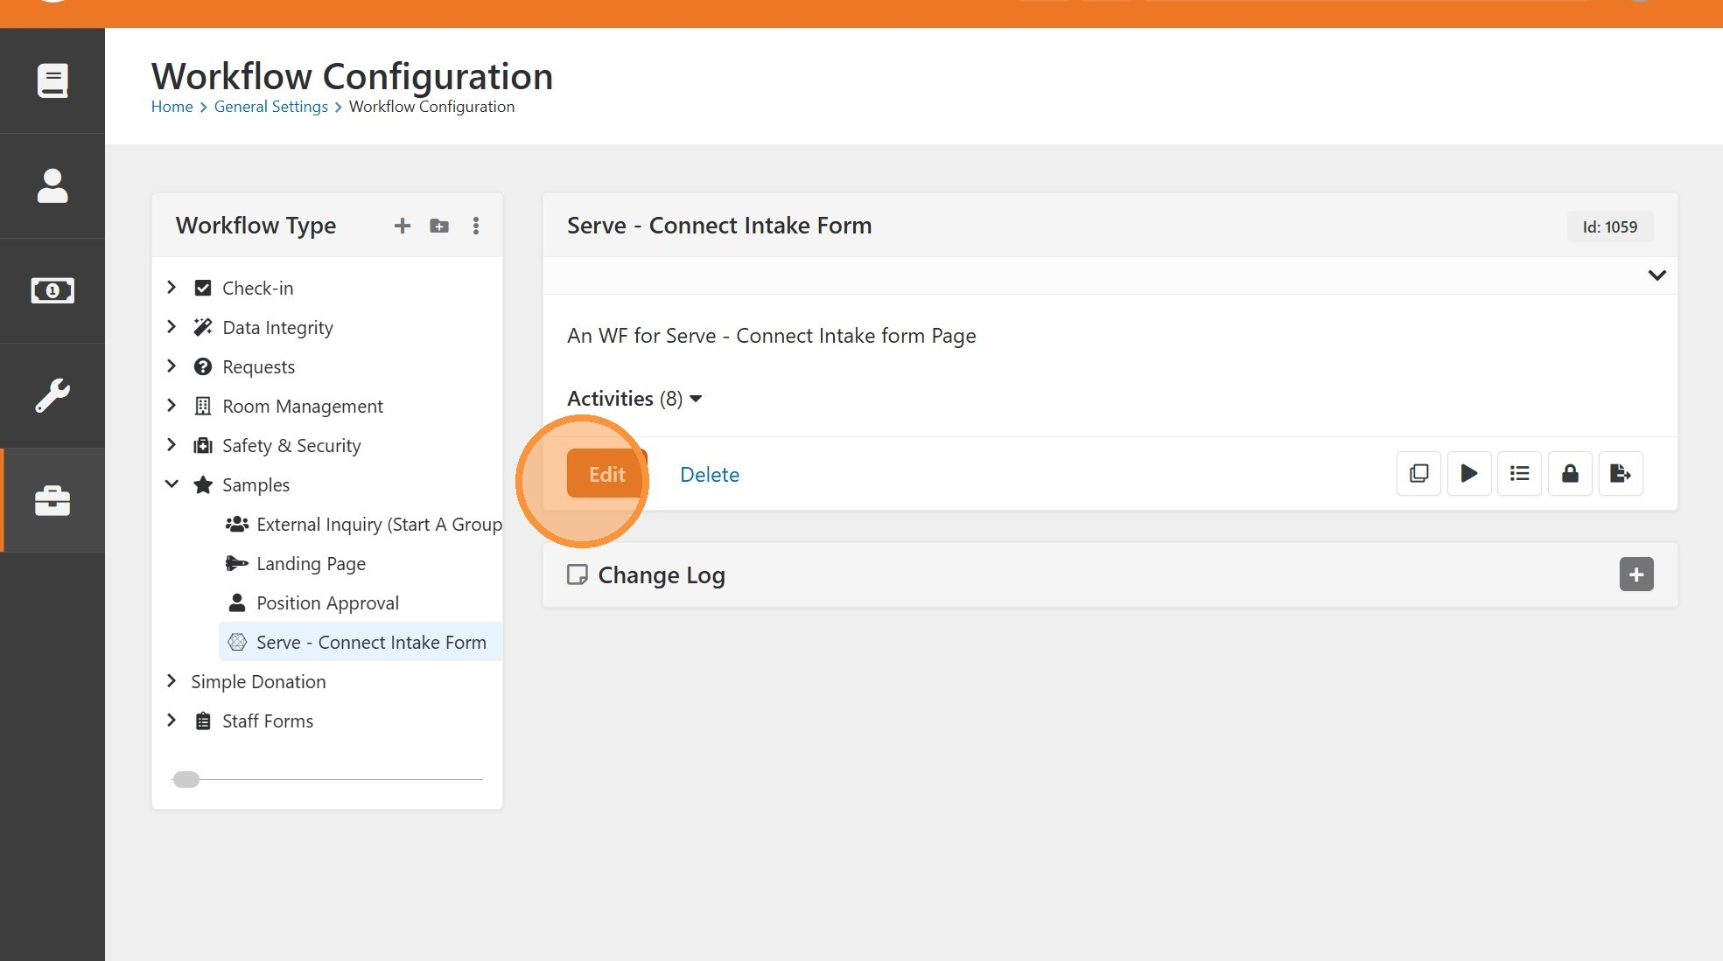
1
Navigate to an existing workflow you would like to add the PMM Background Check Screening Flow v3 action to and click "Edit".

Add New Workflow Attributes
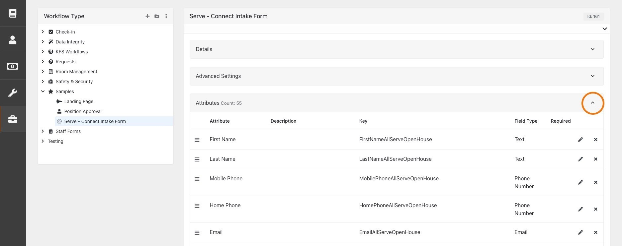
2
Expand the "Attributes" section of the workflow.
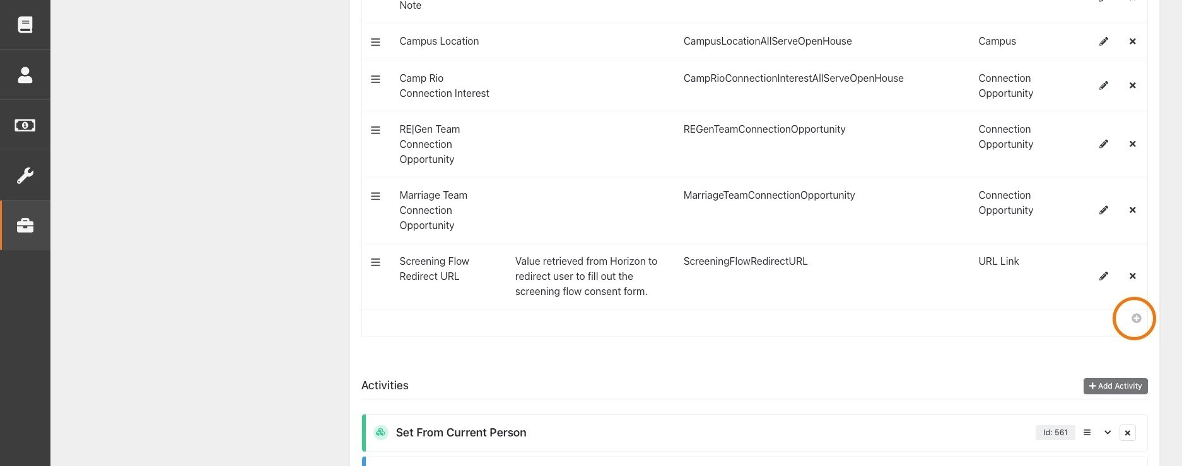
3
Click the plus sign (+) at the bottom right corner of the Attributes panel to add a
Workflow Attribute.
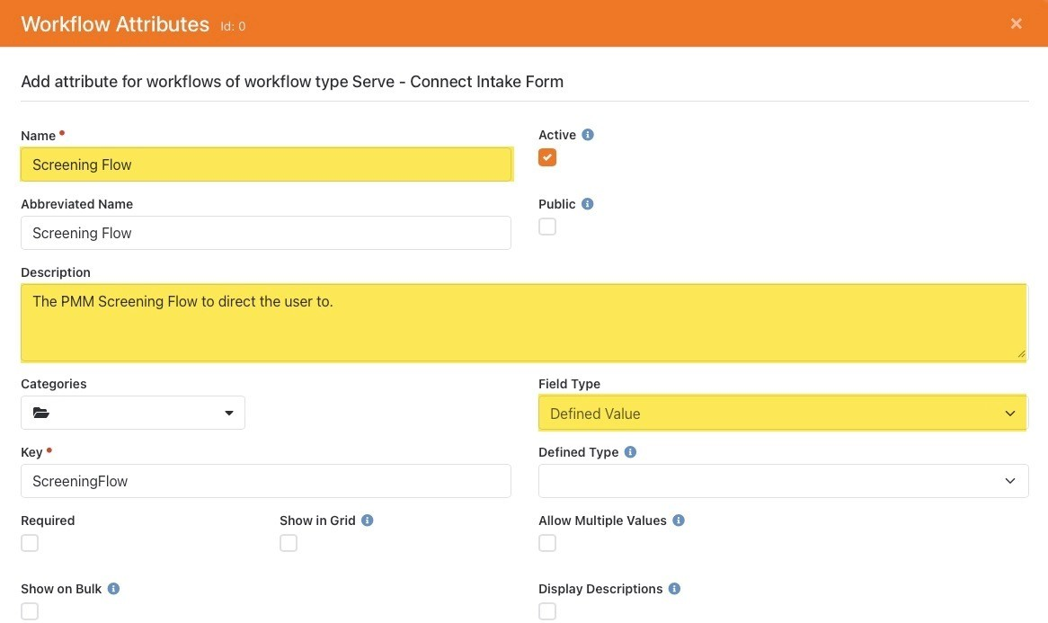
4
Set Name, Description, and Field Type of new attribute.
•
Name: Screening Flow

•
Description The PMM Screening Flow to direct the user to.

:
•
Field Type: Defined Value

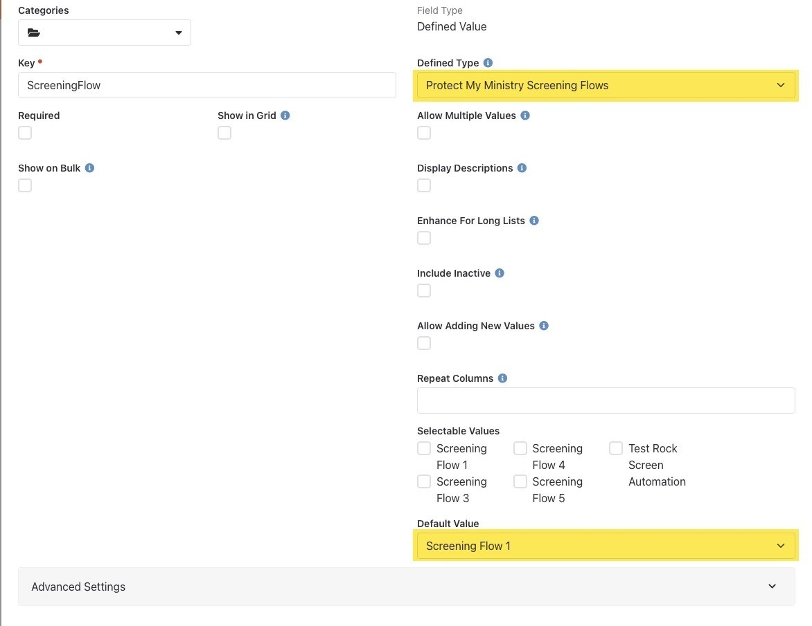
5
Configure attribute settings.
•
Defined Type:
Protect My Ministry Screening Flows
•
Default Value:
Select a screening flow to use as a default. (List is populated from Selectable Values)

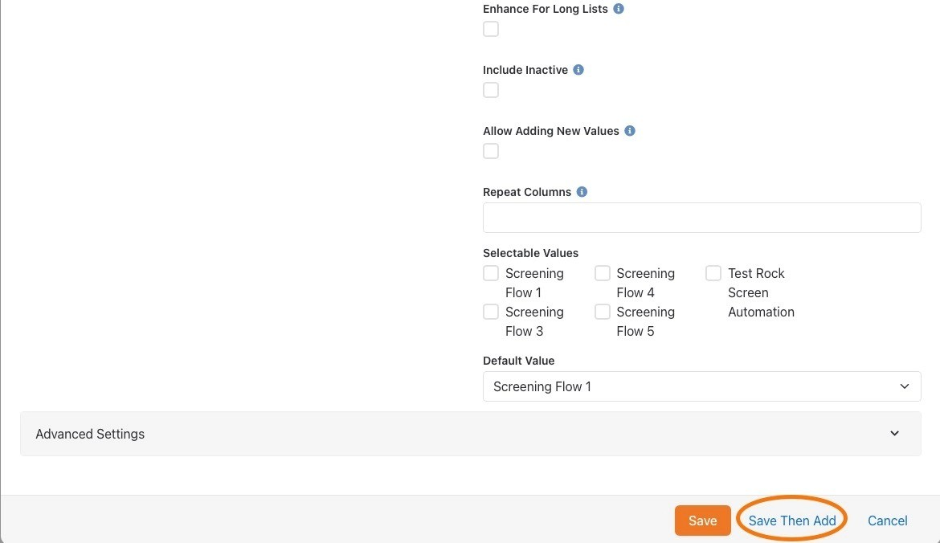
6
Click "Save Then Add" to add a second attribute to the workflow.
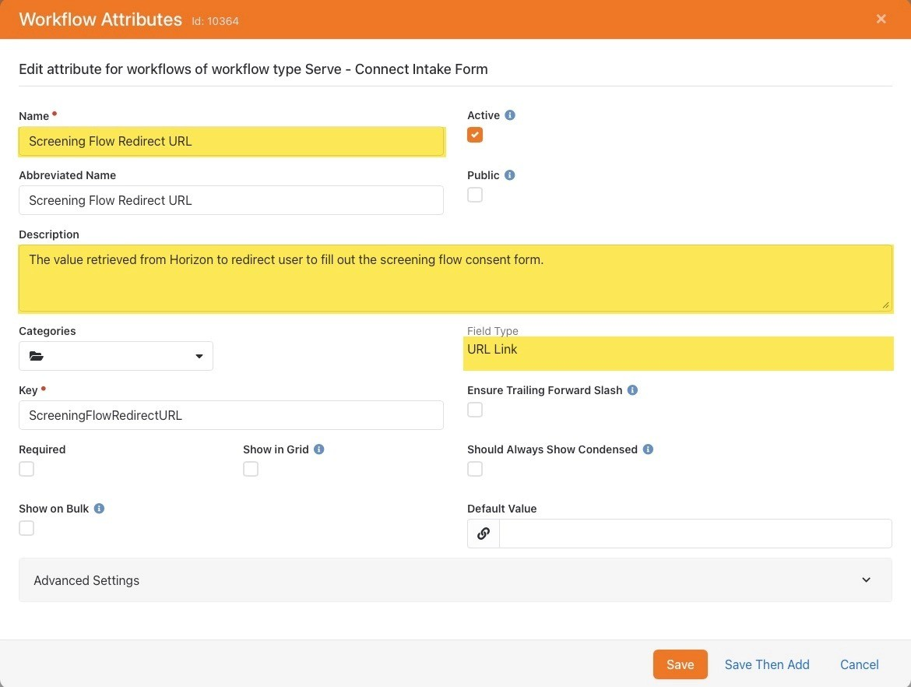
7
Create a new URL Link workflow attribute.
•
Name:
Screening Flow Redirect URL
•
Description:
The value retrieved from Horizon to redirect user to fill out the screening flow consent form.

•
Field Type:
URL Link
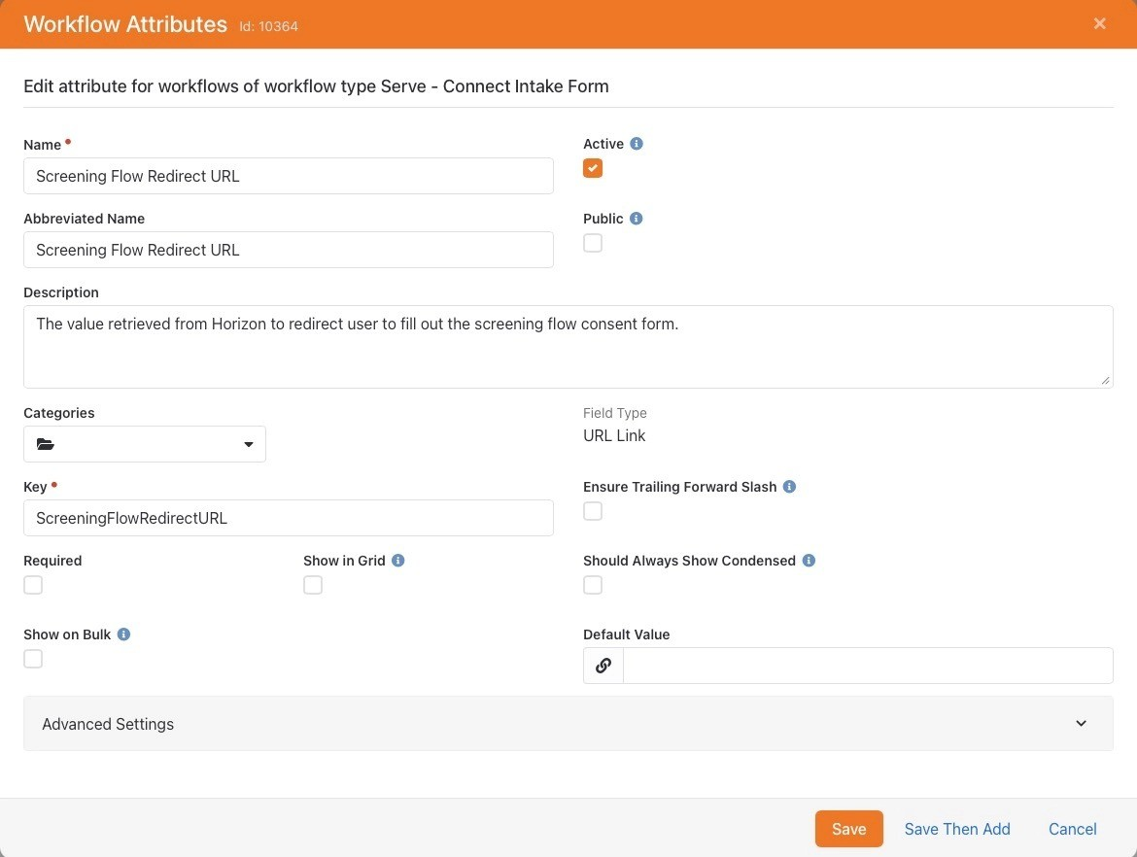
8
Click "Save" to save second workflow attribute.

Add a New Workflow Activity
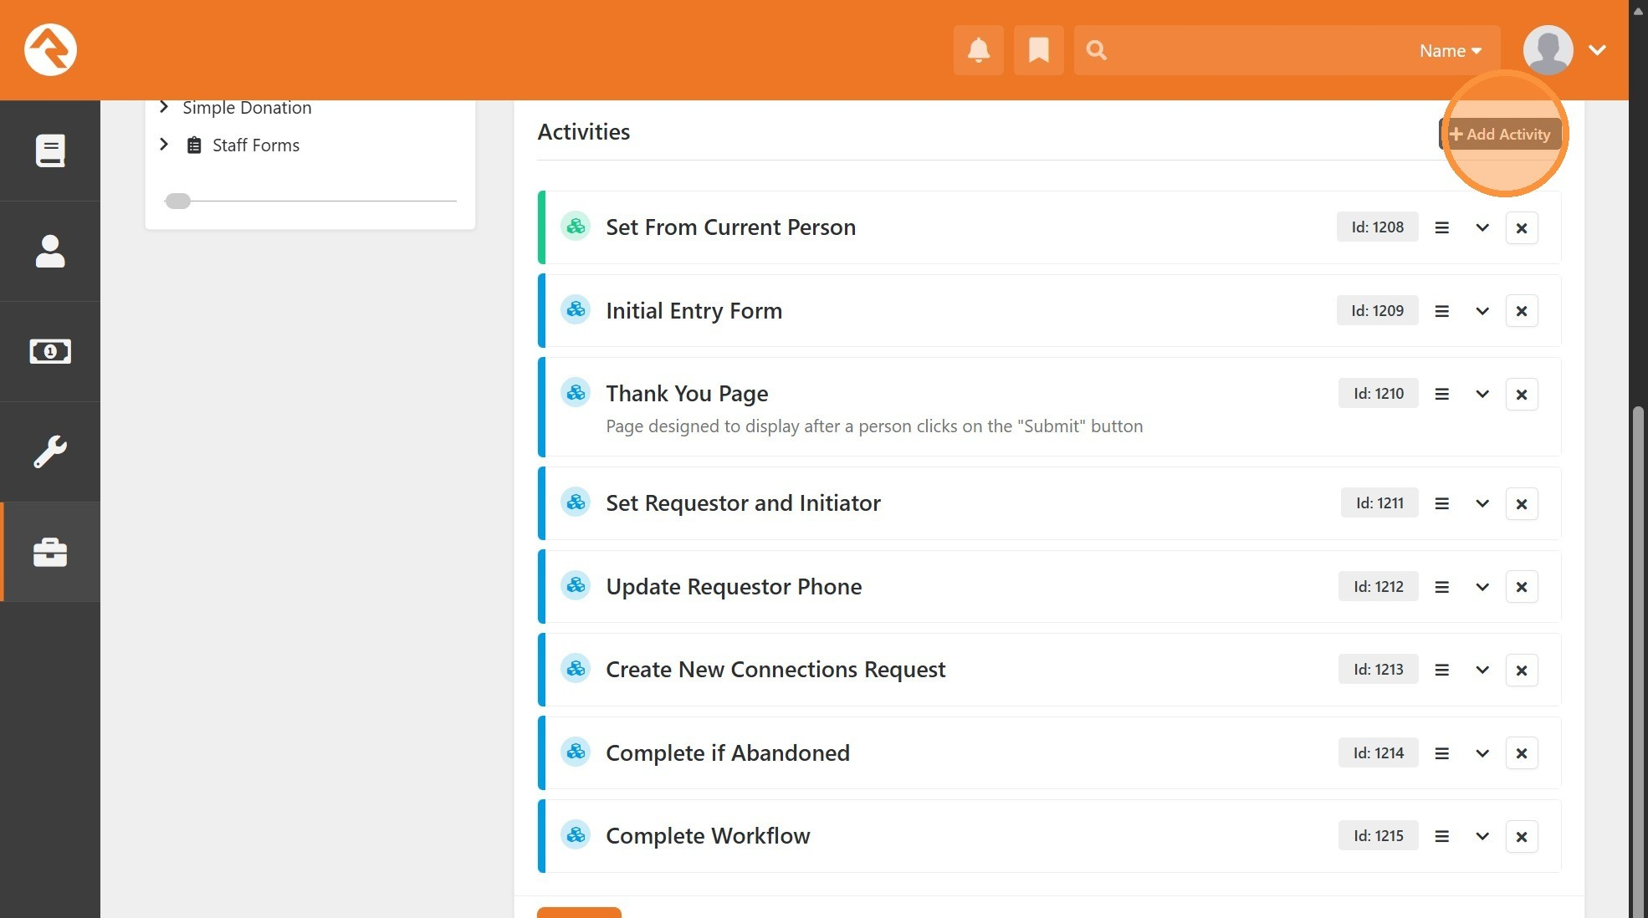
9
Click "Add Activity"
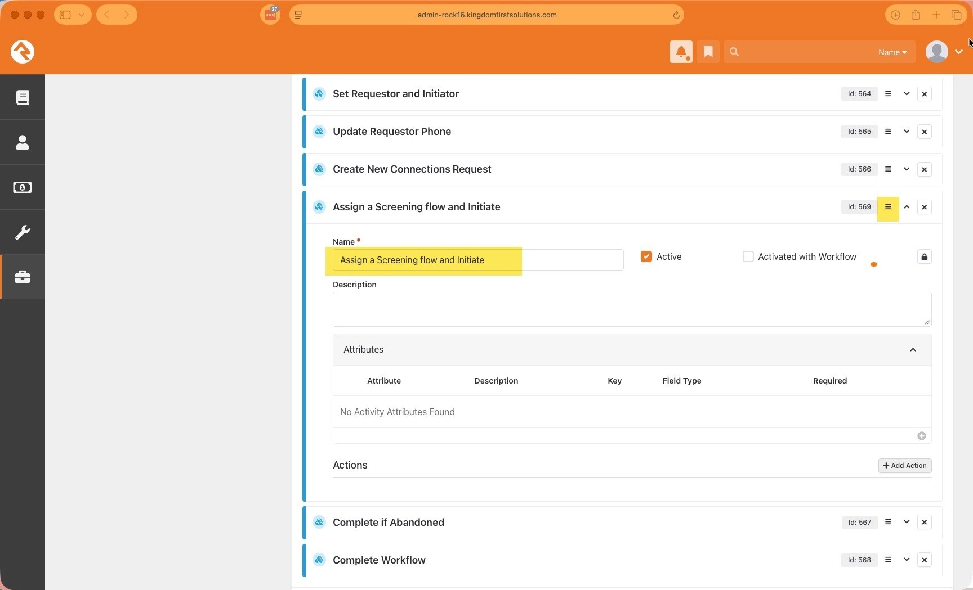
10
Name the new Activity "Assign a Screening flow and Initiate" and move it to where you would like to insert a background check screening request. In this example, we have chosen to run it after a connection request has been created.

Add and Configure Screening Flow Workflow Action
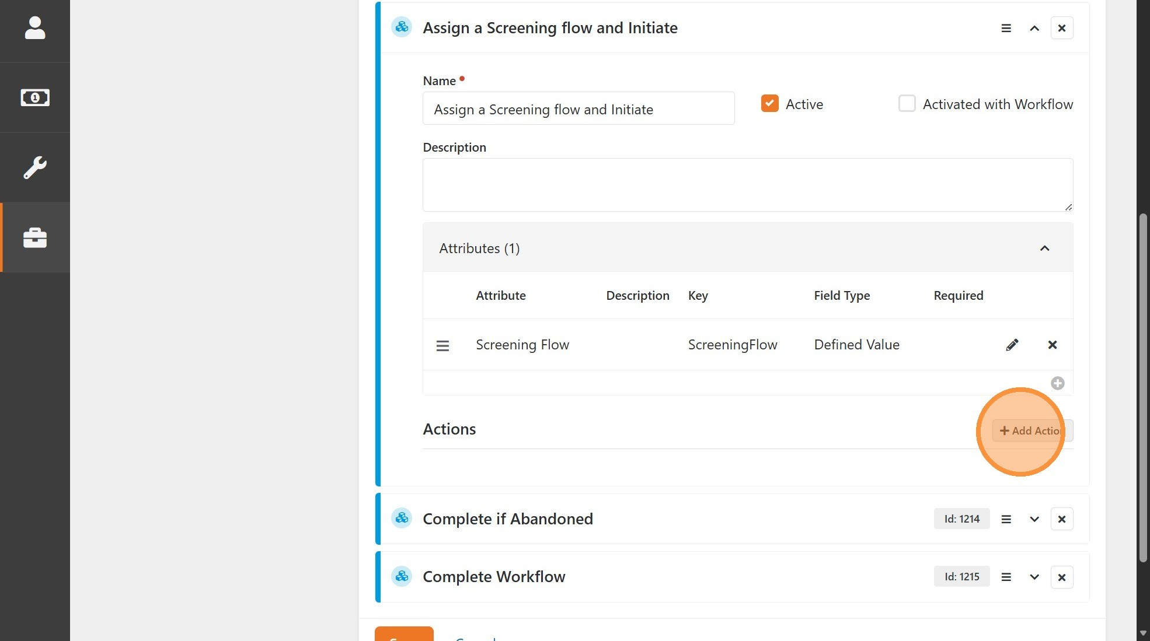
11
Click "Add Action" to add a new action to the activity.
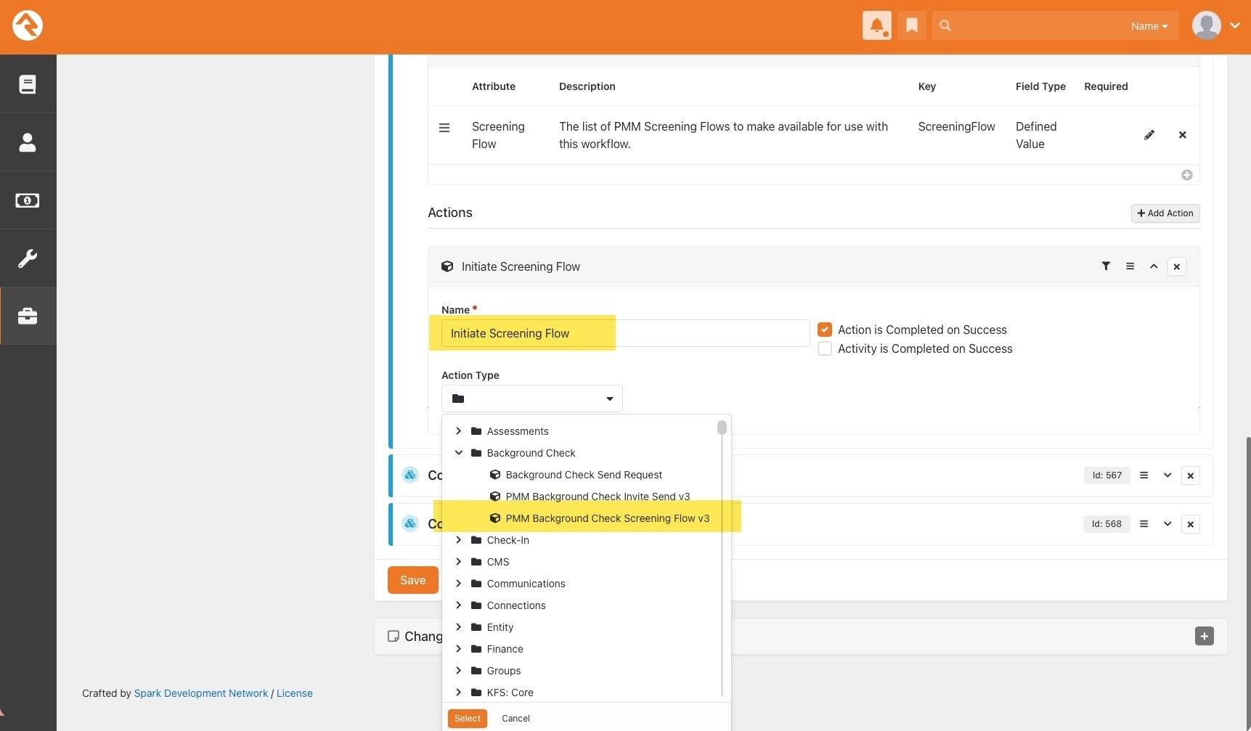
12
Set Name and Action Type of the new action.
•
Name:
Initiate Screening Flow
•
Action Type:
Background Check > PMM Background Check Screening Flow v3
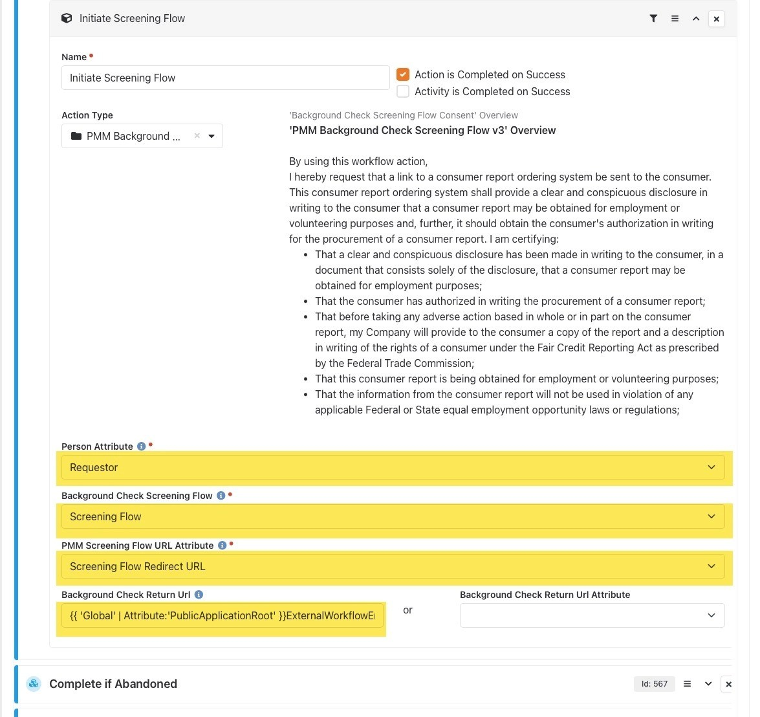
13
Configure action settings.
•
Person Attribute: A Person type attribute in your workflow containing the person the screening is for. This will typically be the person accessing the workflow.

•
Background Check Screening Flow: Select the Screening Flow workflow attribute created earlier.

•
PMM Screening Flow URL Attribute: Select the Screening Flow Redirect URL workflow attribute created earlier.

•
Background Check Return Url: (Optional) The url for the Horizon Screening Flow process to send the user to upon completion. (ex. {{ 'Global' | Attribute:'PublicApplicationRoot' }}ExternalWorkflowEntry/{{ Workflow.WorkflowType.Guid }}/{{ Workflow.Guid }} can be used to return to the current workflow.)

Add and Configure Redirect Workflow Action
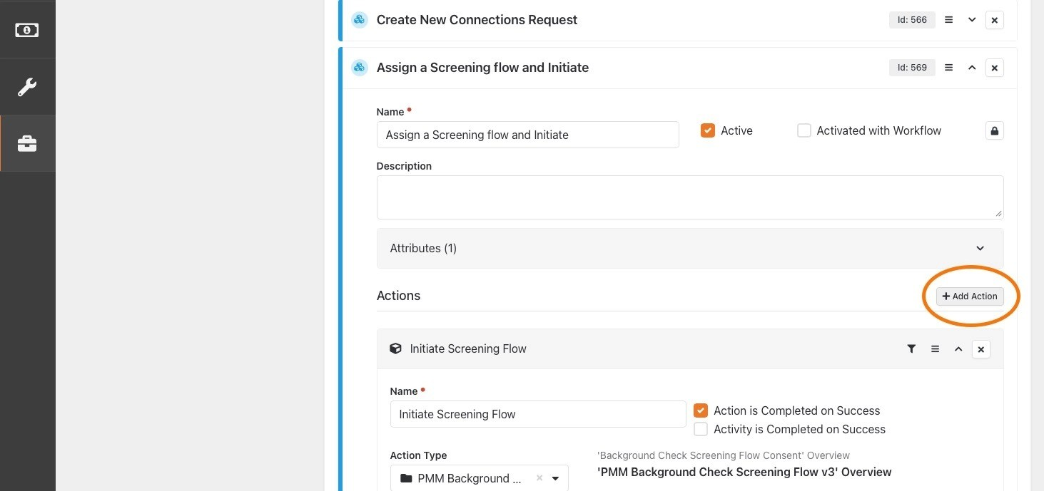
14
Click "Add Action" to add a new action to the activity.
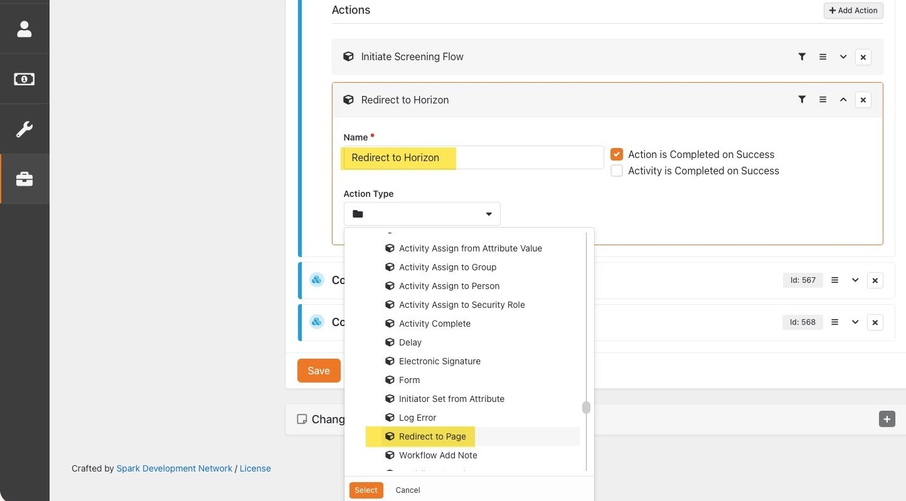
15
Set Name and Action Type of the new action.
•
Name:
Redirect to Horizon
•
Action Type:
Workflow Control > Redirect to Page

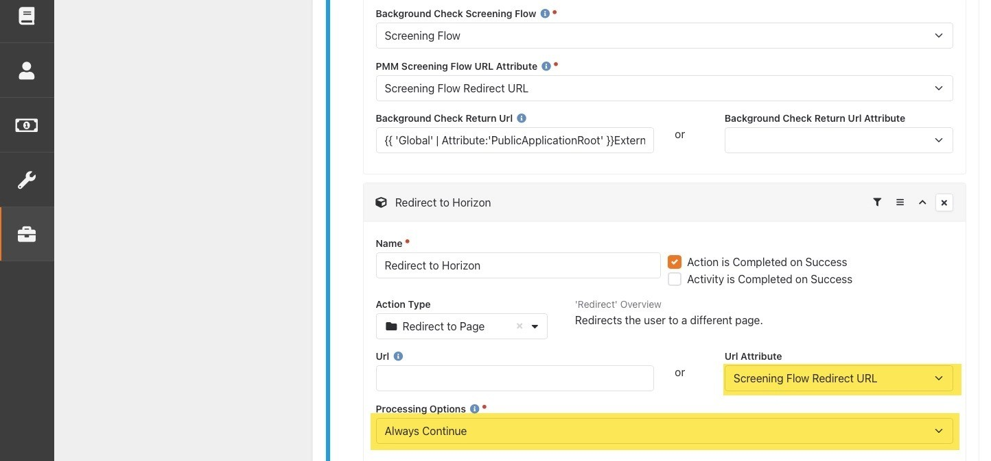
16
Configure action settings.
•
URL Attribute: " Select the same "Screening Flow Redirect URL" activity attribute set as the
PMM Screening Flow URL Attribute" in the previous screening flow action.

•
Processing Options: Set for desired behavior of the action. If unsure, set to "Always Continue".

Add and Configure Activate Activity Workflow Action
17
Click "Add Action" to add a new action to the activity.
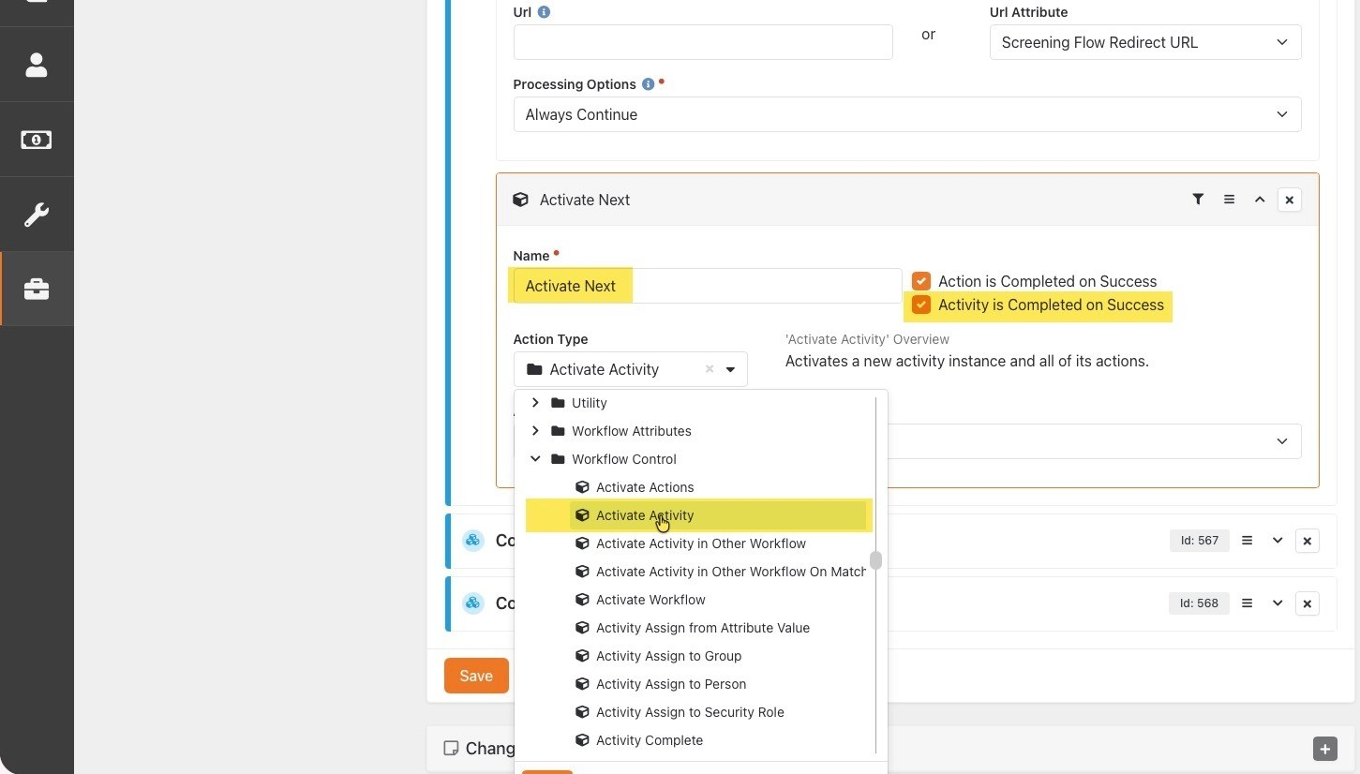
18
Set Name and Action Type of the new action.
•
Name:
Activate Next
•
Action Type:
Workflow Control > Activate Activity
• Check the Activity is Completed on Success checkbox

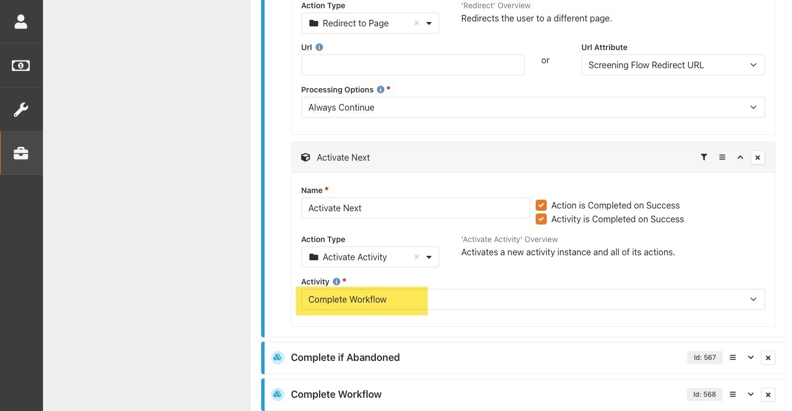
19
Configure action settings.
•
Activity:
Select the activity you would like the workflow to activate after redirecting the user to the Horizon URL.

Enable New Screening Flow Activity
To activate your new screening flow activity, you must first perform the following steps within the existing workflow activity that you want to use as a trigger.
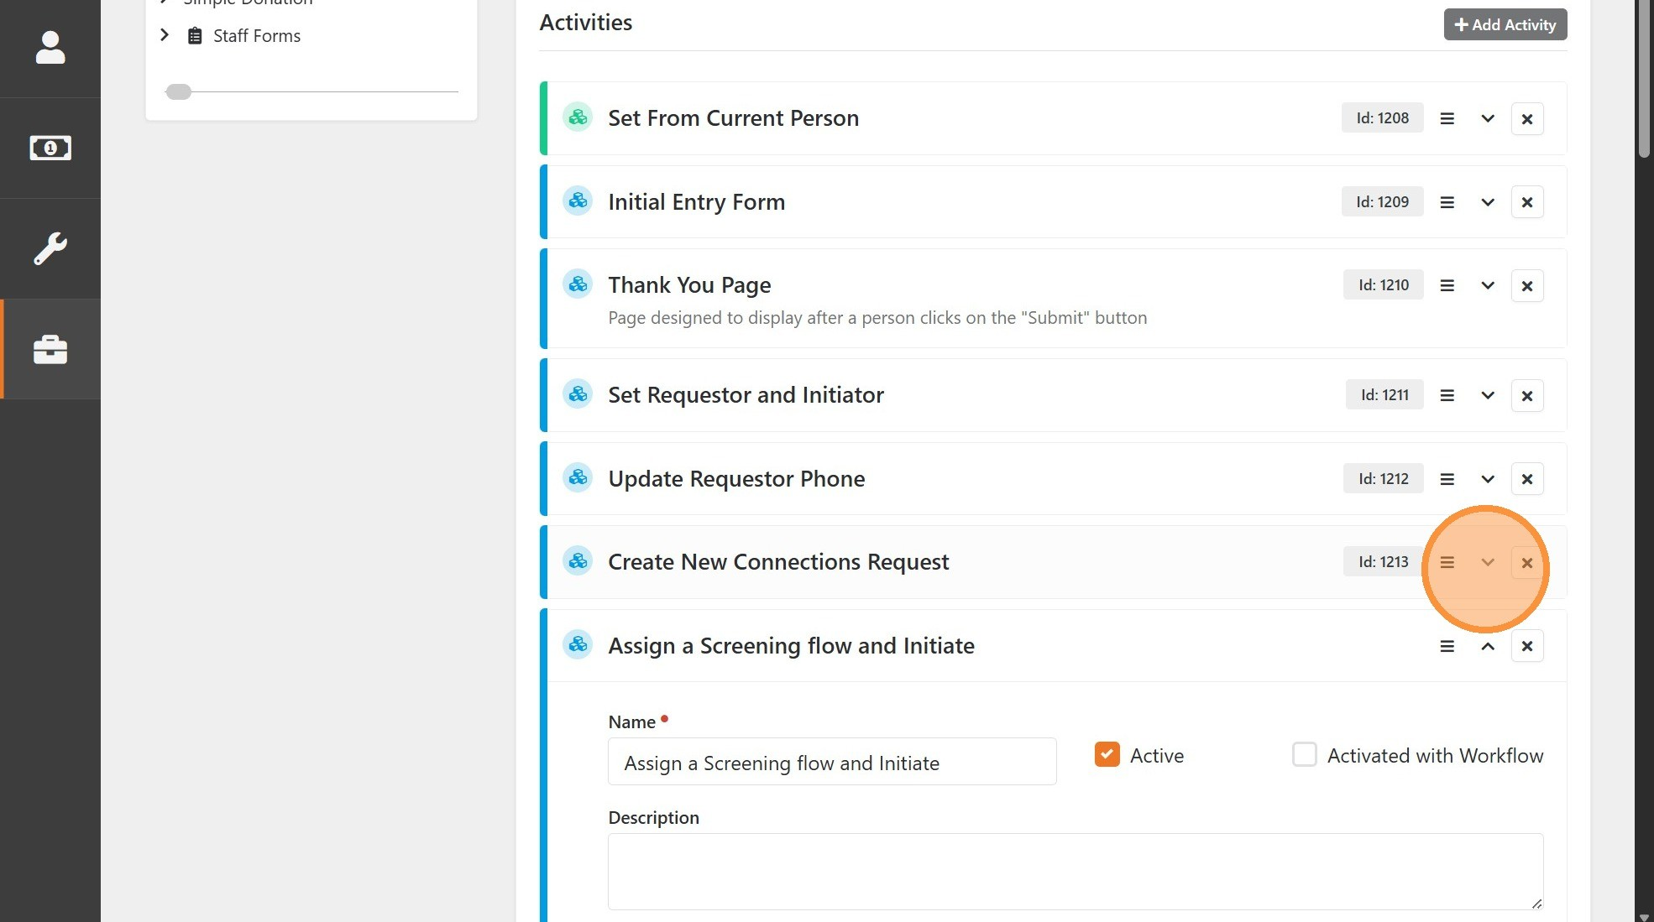
20
Expand the desired trigger activity
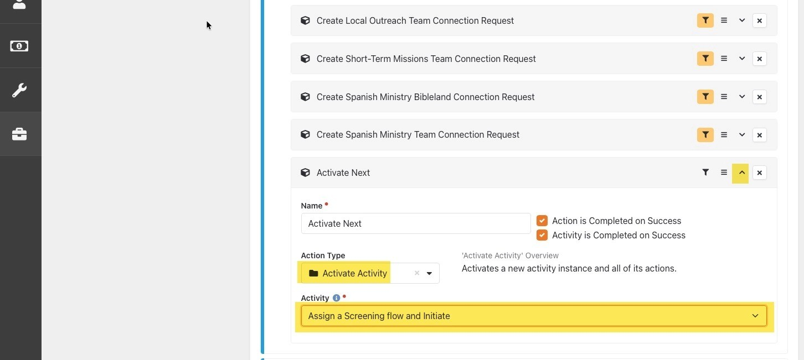
21
Find the previously configured "Activate Activity" type action. Change the Activity setting to "Assign a Screening flow and Initiate".

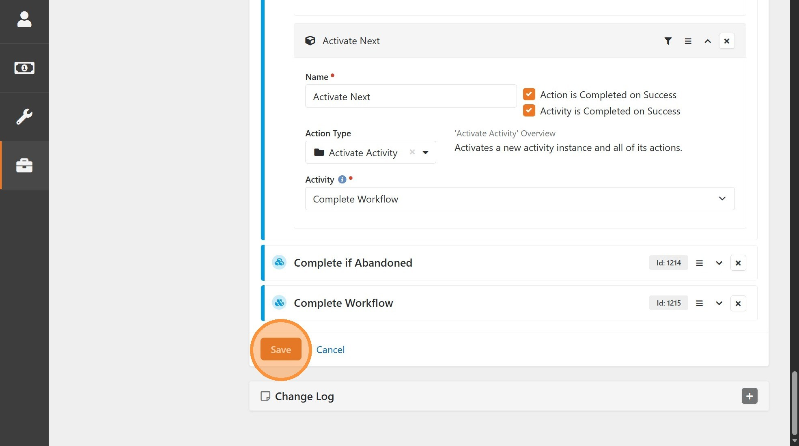
22
Click "Save" to save all workflow changes.

Advanced Option: Dynamically Selected Screening Flow
There are numerous ways to incorporate logic into your workflow to dynamically determine which PMM Screening Flow to utilize. The following example serves as a teaching tool and is not intended as a universally applicable recommendation for every situation.

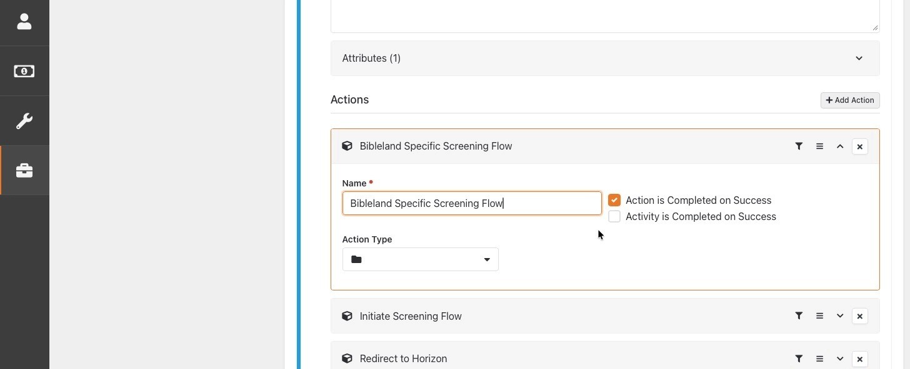
23
Add a new workflow action, give it an appropriate name, and move it somewhere
before the "Initiate Screening Flow" action created above in your workflow.
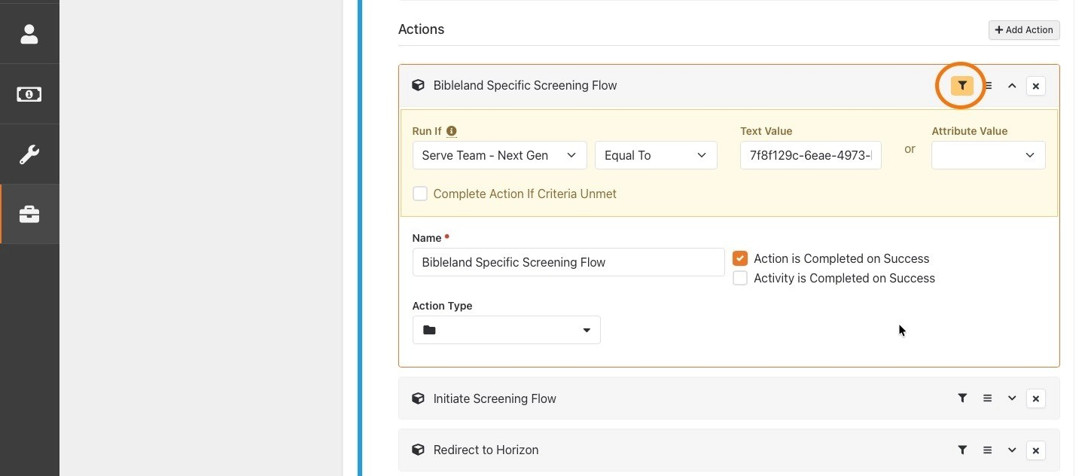
24
Click the filter icon and configure the filter as desired.
•
Run If: Select the attribute you would like to use for comparison criteria. Then select the operator you would like to use for comparison from the second drop down.

•
Text Value or Attribute Value: Provide the value to be evaluated for the Run If comparison. Either provide a hard coded string in Text Value, or set Attribute Value to an attribute containing the value to compare.

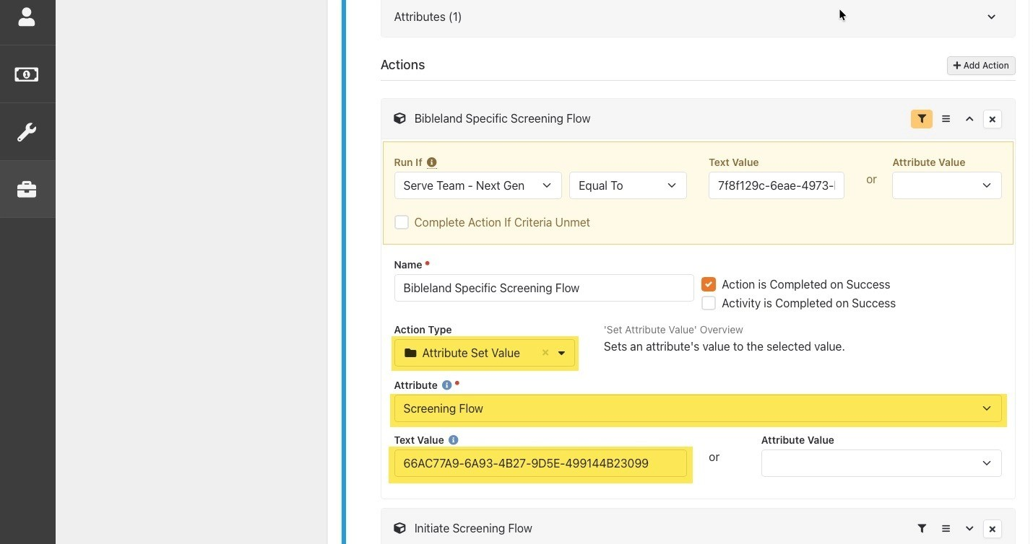
25
Configure action settings.
•
Action Type:
Workflow Attributes > Attribute Set Value
•
Attribute:
Set to previously created "Screening Flow" workflow attribute.
•
Text Value: Set to the Guid of the Defined Value representing the PMM Screening Flow you wish to use for this logic.

26
Click "Save" to save all workflow changes.

Advanced Option: Check for Existing Background Check
The following example demonstrates how to add a check for an existing valid background check within the past year in Rock before processing a new request. It simulates the same process the default workflow imported by the plugin uses.
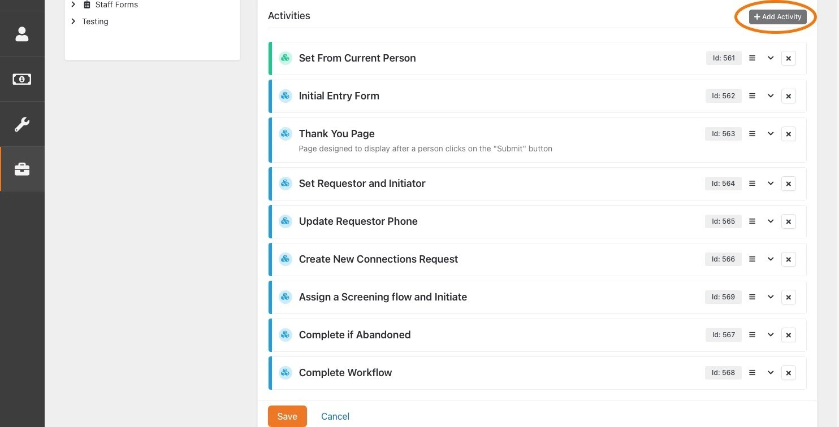
27
Click "Add Activity".
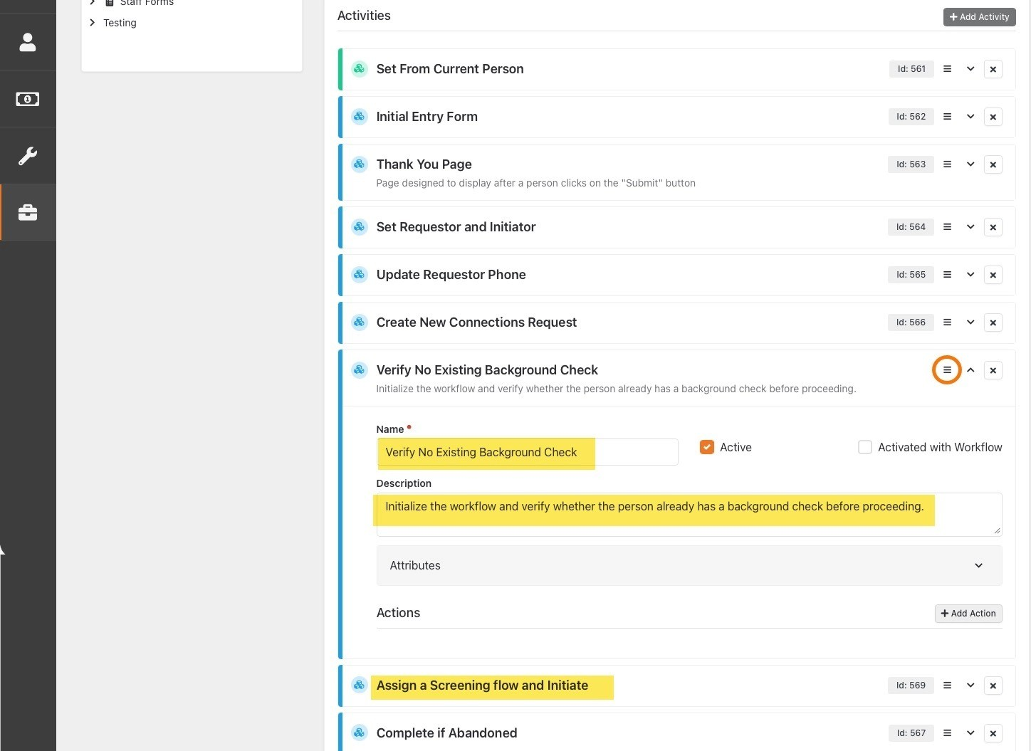
28
Set the Name and Description of the new activity and move it just before the
"Assign a Screening flow and Initiate" activity created in the previous section.
NOTE: Though there is not a specific order required for this activity when using
the "Activate Activity" actions, we recommend you placing it immediately before
the screening flow activity for visual flow.
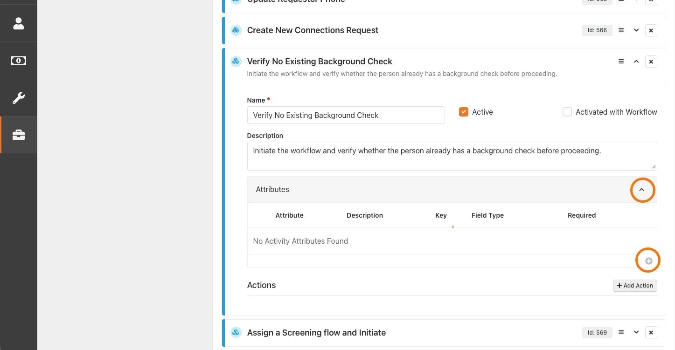
29
Expand the "Attributes" section of the new activity and click the plus sign to add an
attribute to the activity.
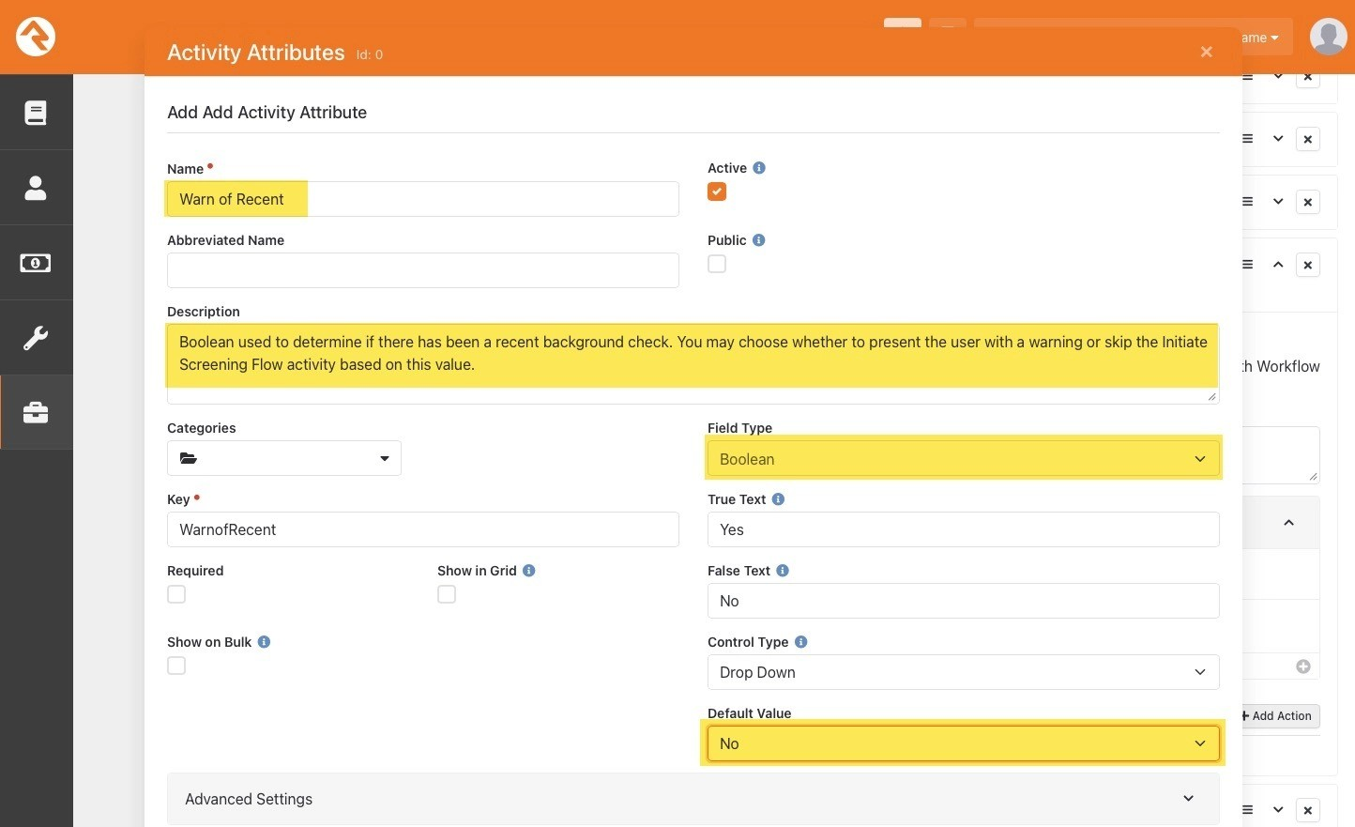
30
Configure attribute settings.
•
Name:
Warn of Recent
•
Description: Boolean used to determine if there has been a recent background check. You may choose whether to present the user with a warning or skip the Initiate Screening Flow activity based on this value.

•
Field Type:
Boolean
•
Default Value:
No
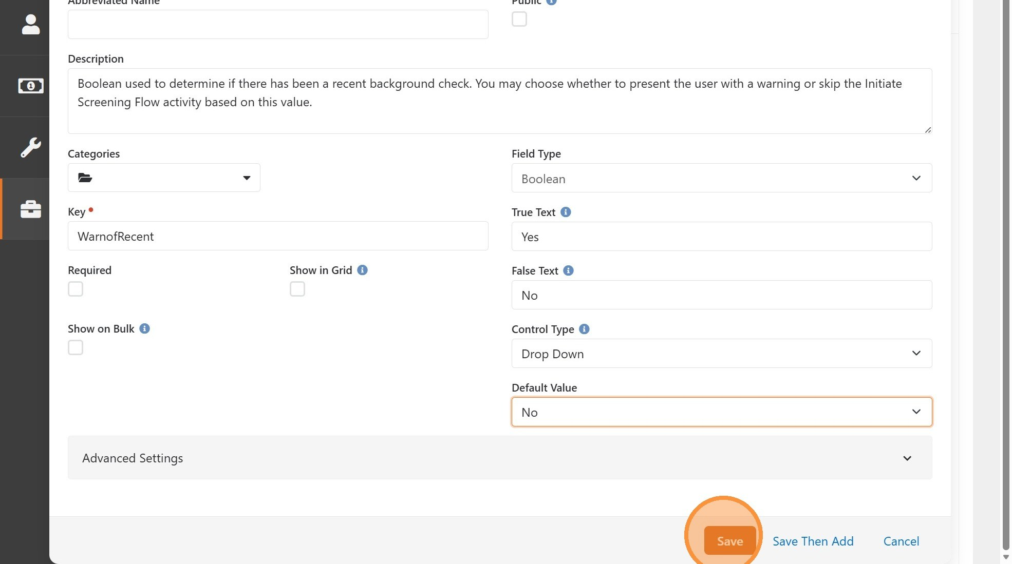
31
Click "Save".
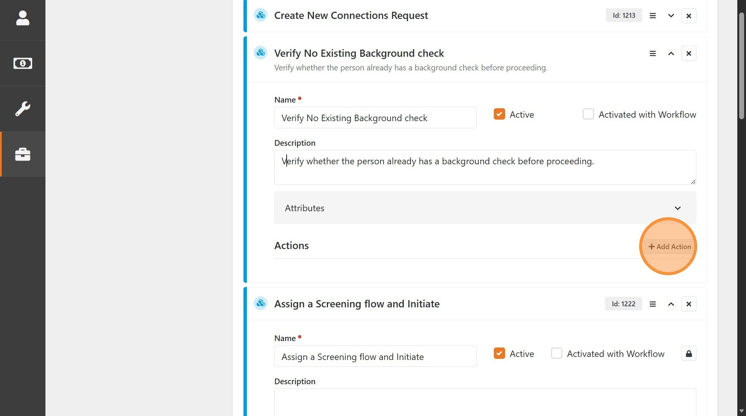
32
Click "Add Action" to add a new action to the activity.
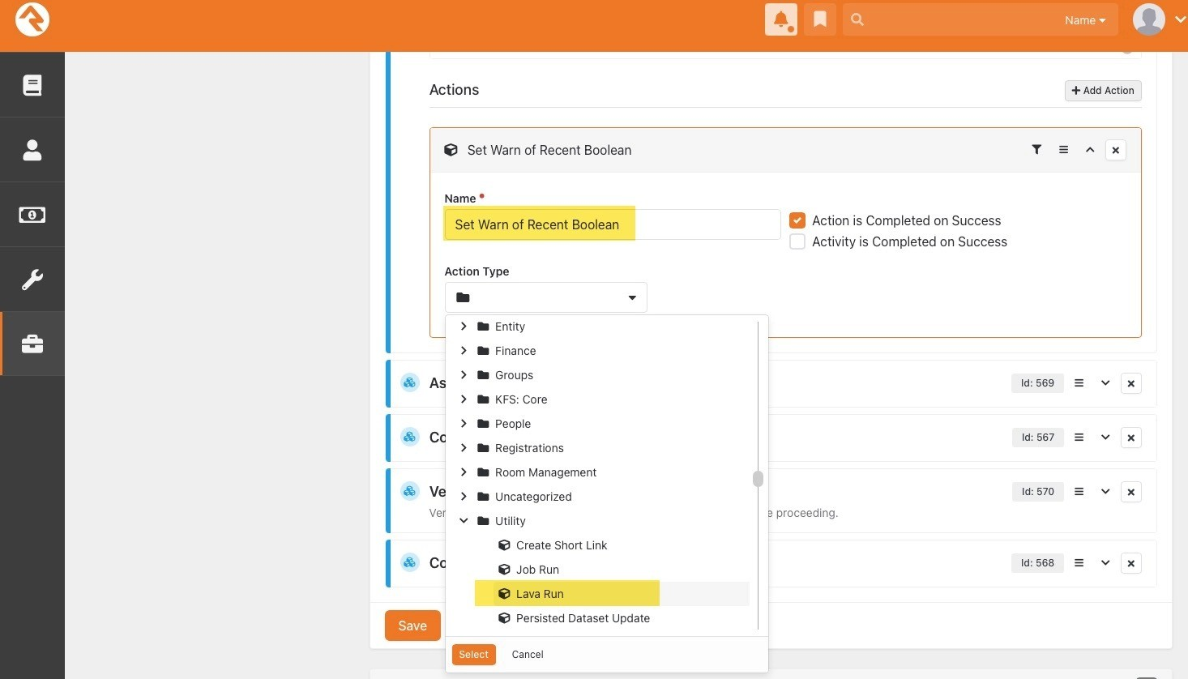
33
Set Name and Action Type of the new action.
•
Name:
Set Warn of Recent Boolean
•
Action Type:
Utility > Lava Run
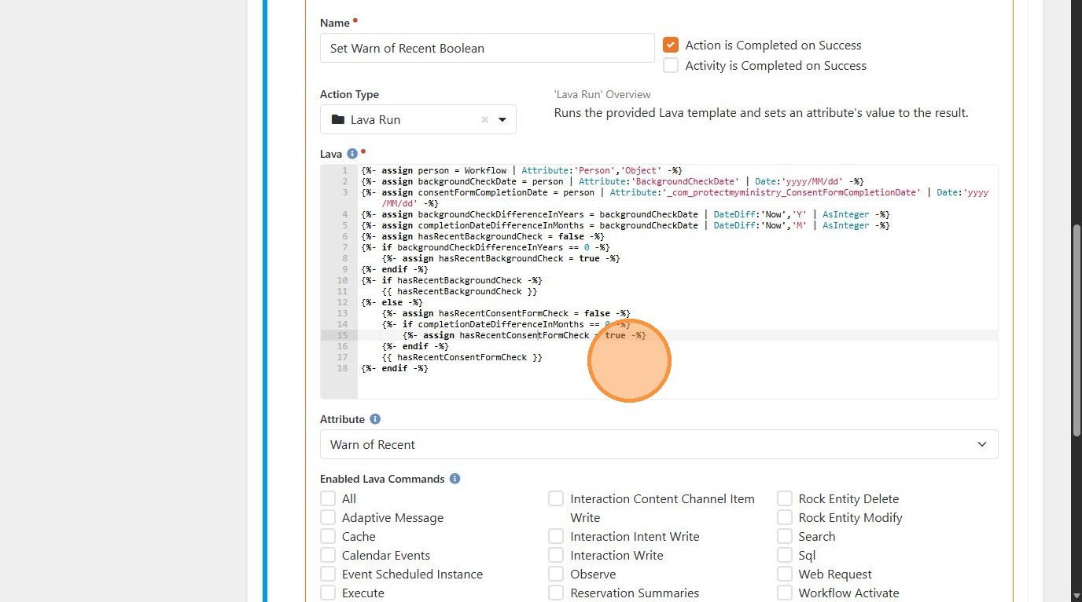
34
Configure action settings.
•
Attribute: Set to "Warn of Recent" activity attribute created above.

•
Lava: Provide lava code with logic to set the attribute as desired. (See Sample Lava
below)

Sample Lava
The lava below performs logic to determine if a person has an active background check in within the past year by checking their Background Check Date attribute. Or has a recent Screening Flow Consent Form submitted within the past month by checking their Consent Form Completion Date attribute.
This lava makes the following assumptions:
- A Person type workflow attribute with the Key "Person" exists, and has been set to the person to check.
- The Person attribute "Background Check Date" has not been modified in any way.
- The Person attribute "Consent Form Completion Date" has not been modified in any way.

Lava:
{%- assign person = Workflow | Attribute:'Person','Object' -%}
{%- assign backgroundCheckDate = person | Attribute:'BackgroundCheckDate' |
Date:'yyyy/MM/dd' -%}
{%- assign consentFormCompletionDate = person |
Attribute:'_com_protectmyministry_ConsentFormCompletionDate' |
Date:'yyyy/MM/dd' -%}
{%- assign backgroundCheckDifferenceInYears = backgroundCheckDate | DateDiff:'Now','Y' | AsInteger -%}
{%- assign completionDateDifferenceInMonths = backgroundCheckDate |
DateDiff:'Now','M' | AsInteger -%}
{%- assign hasRecentBackgroundCheck = false -%}
{%- if backgroundCheckDifferenceInYears == 0 -%}
{%- assign hasRecentBackgroundCheck = true -%}
{%- endif -%}
{%- if hasRecentBackgroundCheck -%}
{{ hasRecentBackgroundCheck }}
{%- else -%}
{%- assign hasRecentConsentFormCheck = false -%}
{%- if completionDateDifferenceInMonths == 0 -%}
{%- assign hasRecentConsentFormCheck = true -%}
{%- endif -%}
{{ hasRecentConsentFormCheck }}
{%- endif -%}
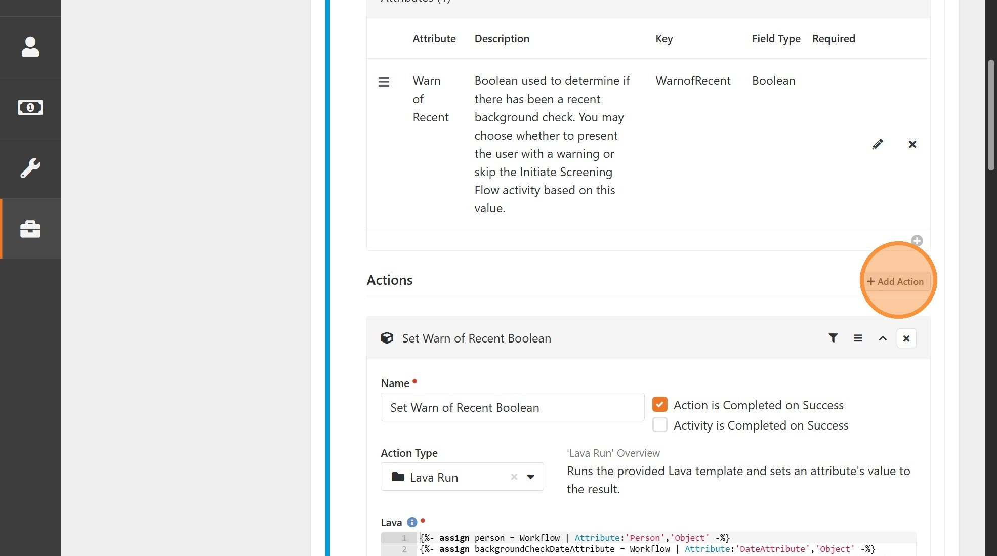
35
Click "Add Action" to add a second action to the activity.
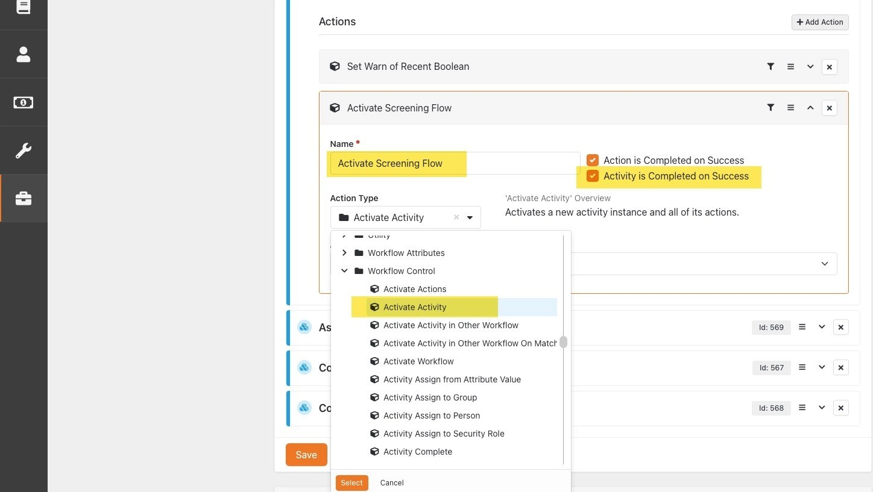
36
Set Name and Action Type of new Action.
•
Name:
Activate Screening Flow
•
Action Type:
Workflow Control > Activate Activity
• Check the Activity is Completed on Success checkbox

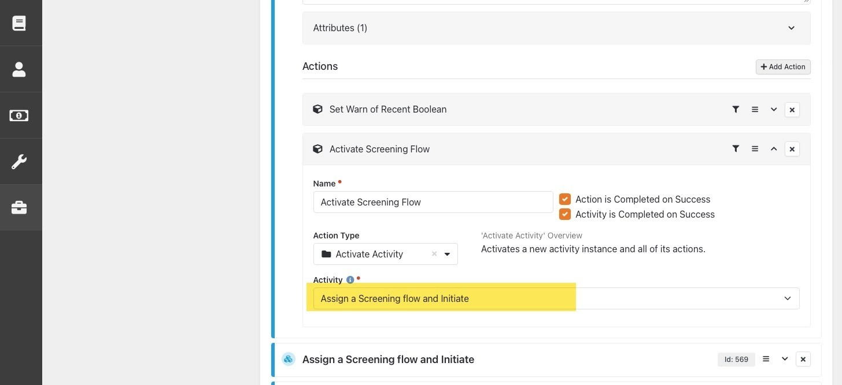
37
Configure action settings.
•
Activity: Select the "Assign a Screening flow and Initiate" activity from the previous section
of this guide.

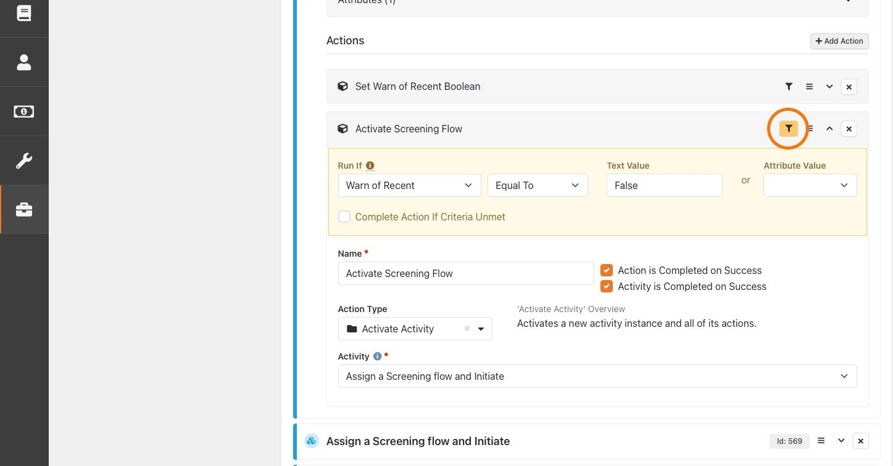
38
Click the filter icon and configure the filter.
•
Run If: Select "Warn of Recent" activity attribute, then select "Equal To" from the comparison operator drop down.

•
Text Value:
"False" (without quotation marks)
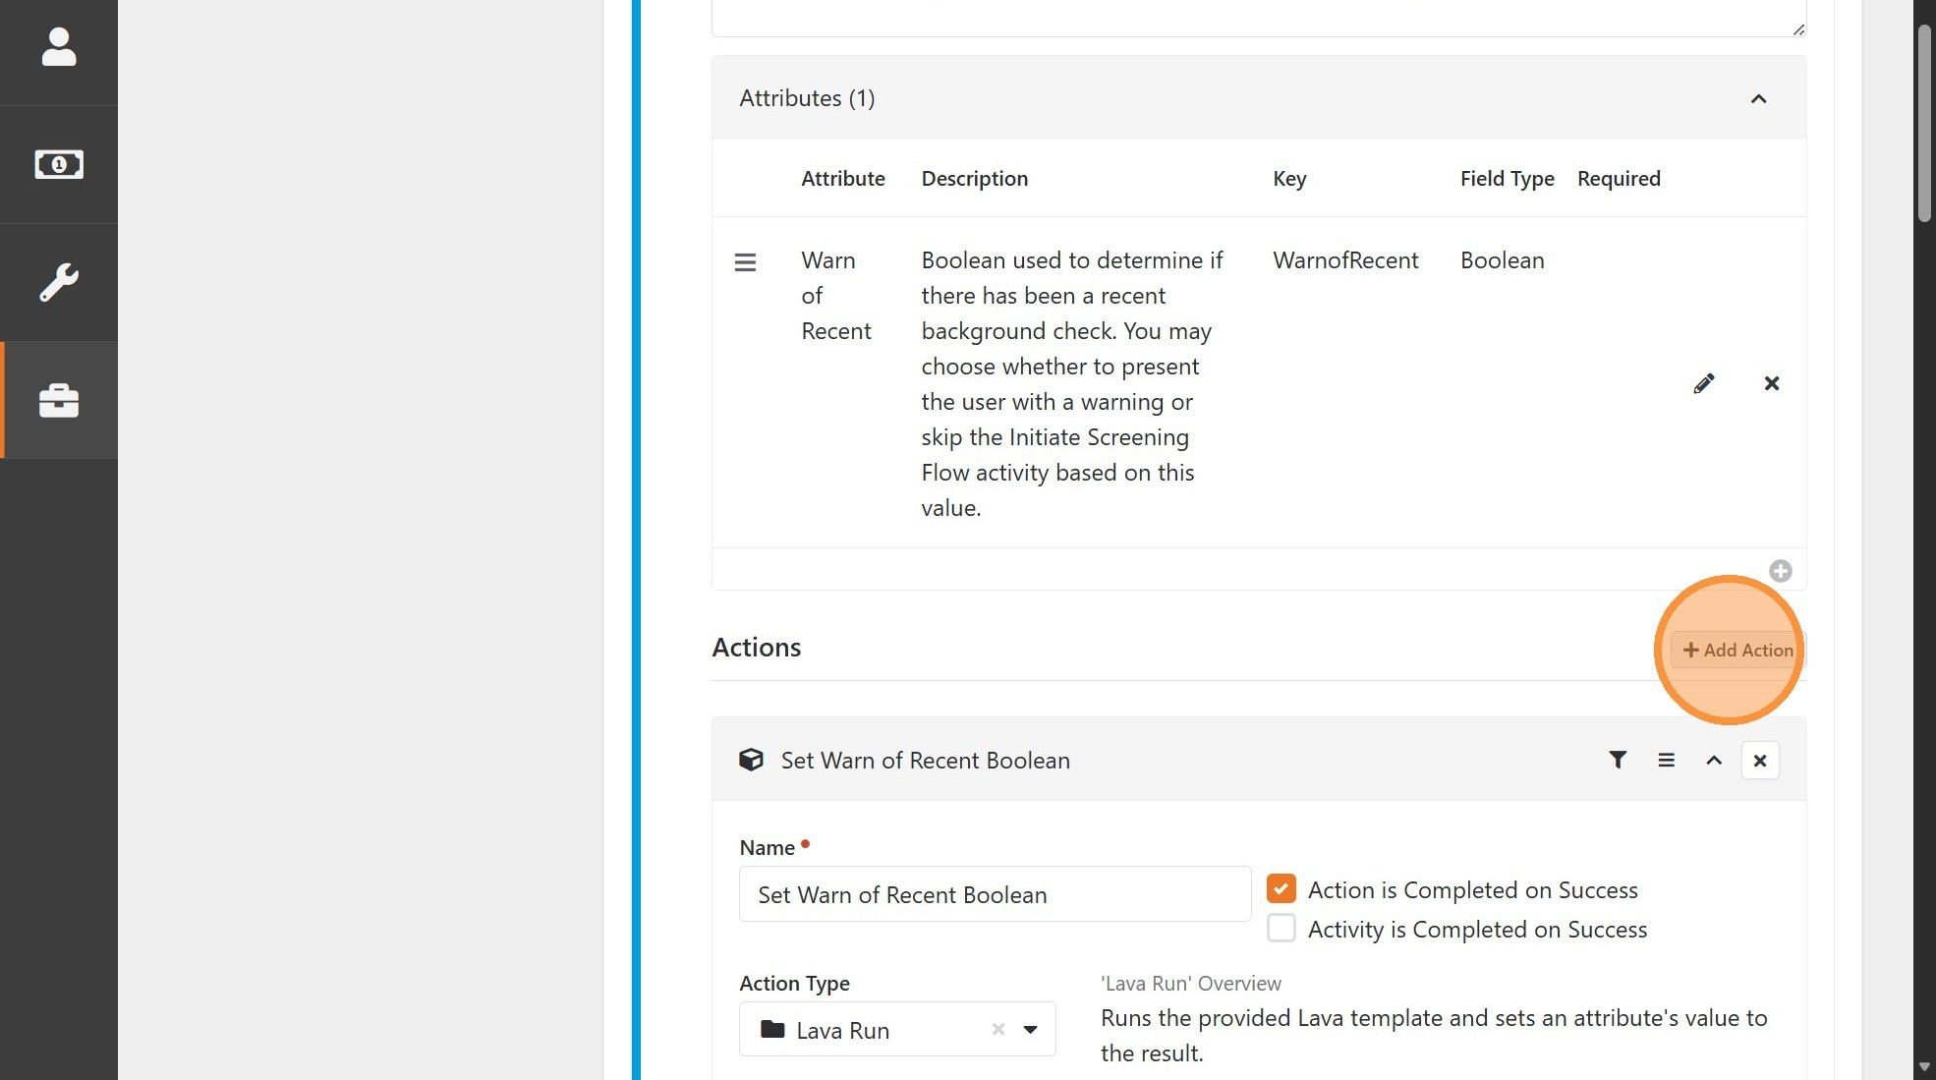
39
Click "Add Action" to add a third action to the activity.
NOTE: This action will handle the scenarios where the previous action did not run
because its filter criteria was not met.
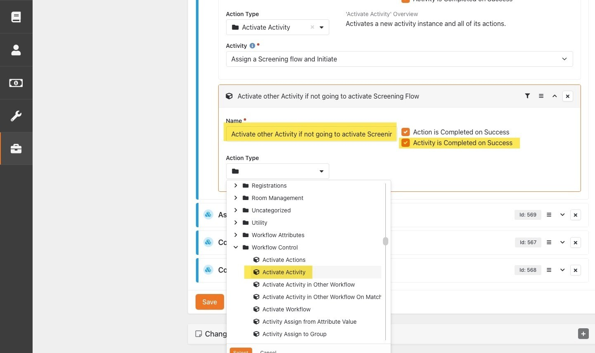
40
Set Name and Action Type of new Action.
•
Name:
Activate other Activity if not going to activate Screening Flow
•
Action Type:
Workflow Control > Activate Activity
• Check the Activity is Completed on Success
checkbox

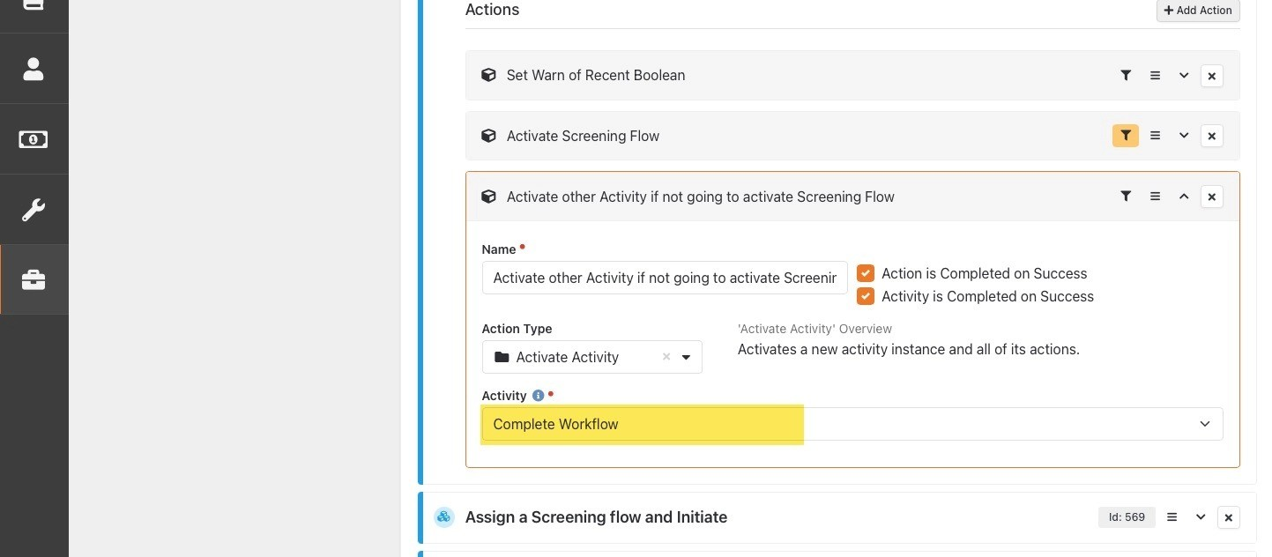
41
Configure action settings.
•
Activity: Select the activity you would like the workflow to activate if the person meets the criteria of having an existing background check.

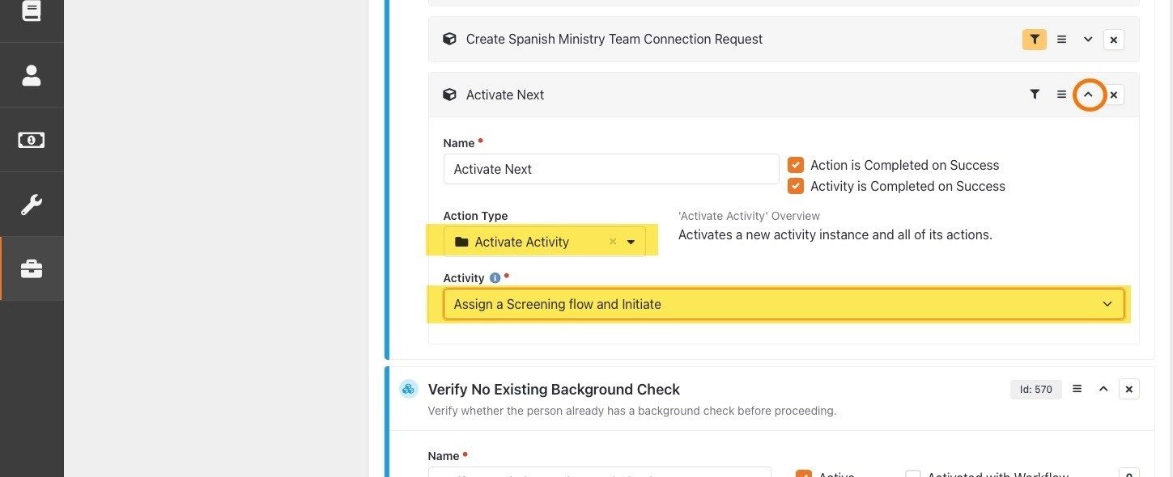
42
Find and expand the Activity and Action containing the Activate Activity that
originally activated the Screening Flow activity. For the example in this guide, this
is the "Activate Next" action within the "Create New Connections Request" activity.
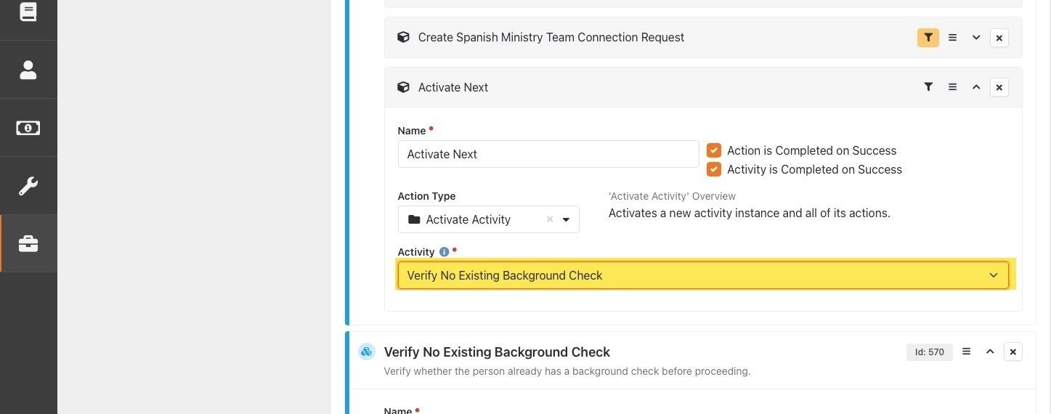
43
Change the
Activity
setting to "Verify No Existing Background check".

44
Click "Save" to save all workflow changes.

