ROCK BACKGROUND CHECK TYPES – Setting up the PLUS

[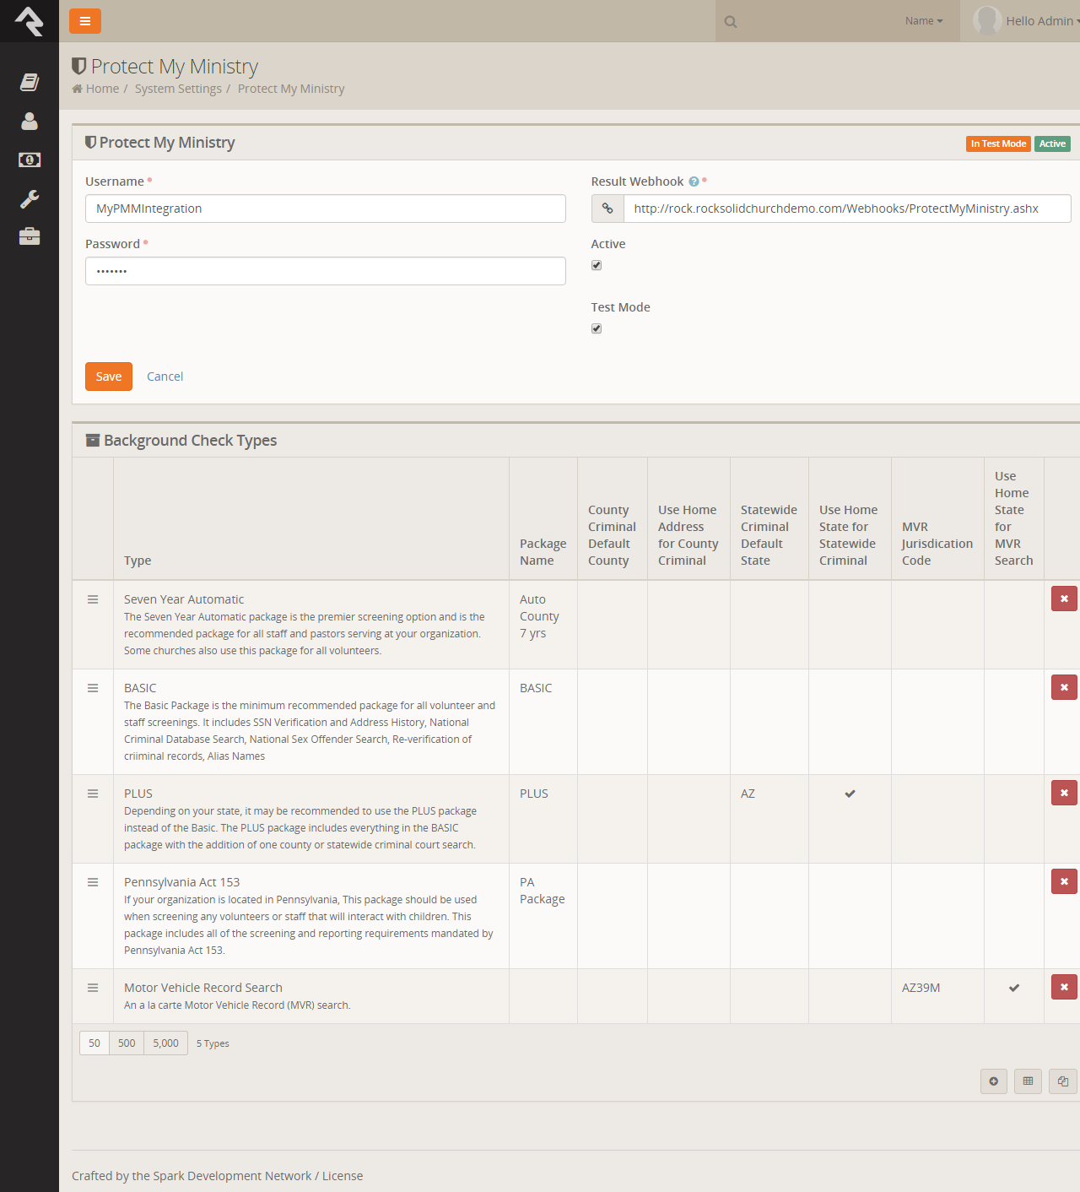](https://www.rockrms.com/Rock/BookContent/9/64)

**Terms**:

* **Package Name** This is the PMM name for the package. It must be an exact match to what's in their system, so please don't change it unless instructed to.
* **County Criminal Default County** Depending on your state it may be recommend that you provide a county on your request. If so this will be the default county to use if one is not present on the address of the person you're checking. You can find out if your state needs this county using [this map from PMM](http://criminal-background-checks.info/).
* **Use Home Address for County Criminal** Again this will depend on the state you live in. If your state is recommended for the county search, you will want to enable this option.
* **State Criminal Default State** This is the default state to use when doing a state criminal request. This option is defaulted to the state that is most common in your database, but feel free to change it.
* **Use Home State for Statewide Criminal** This setting determines if the state from the address should be sent.
* **MVR Jurisdiction Code** This setting determines jurisdiction to use for MVR (Motor Vehicle Records) searches. You can select your area from the list provided. (this is only needed for MVR type searches).
* **Use Home State for MVR Search** This determines if the state from the home address should be sent for the MVR search. (this is only needed for MVR type searches).

Click on the Package Name under the “Type” column to edit the packages. The editing screen will look like the following:

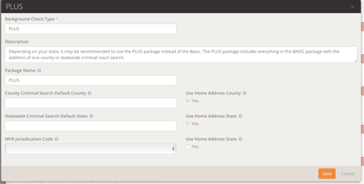

**BASIC Package** – Does not require any options to be selected

**PLUS Package**:

*Statewide* – One of the Statewide options need to be selected, in order for a Statewide search to be ordered. Either the “Statewide Criminal Default State” or the “Use Home Statewide Criminal”

**Note**: Choosing the Use Home Statewide Criminal will only run a statewide in the State the applicant has in their current address

**Note**: When choosing the Statewide Criminal Default State, you will need to abbreviate the state, or else there will be an error

*County* – One of the Statewide options will need to be selected, as well as a County option. Either the County Criminal Default County” or “Use Home Address for County Criminal”.

**Note:** Make sure that there is a County in the applicant’s address when selecting the “Use Home Address for County Criminal”. You will need to go into the applicant’s profile and edit their address to add a County

EX:

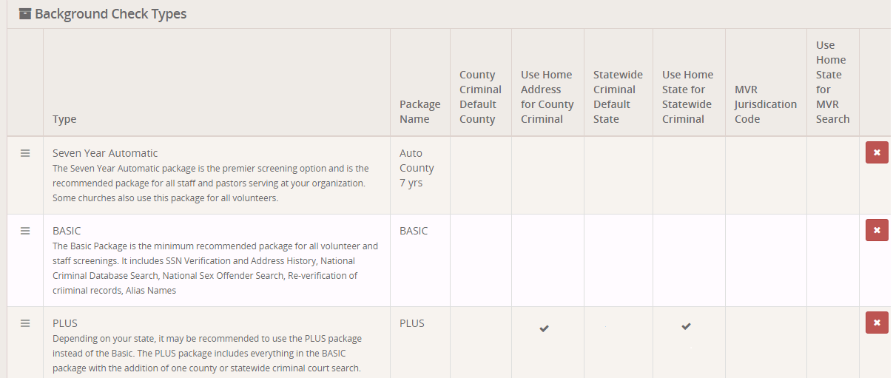

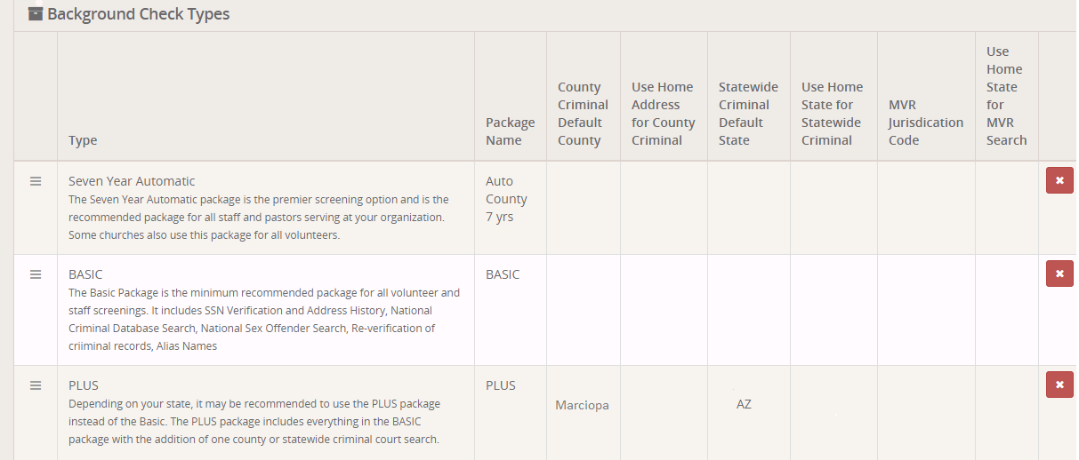

**Motor Vehicle Record Search** – One of the MVR options will need to be selected, either the “MVR Jurisdiction Code” or the “Use Home State for MVR Search”.

**Note:** Selecting the MVR Jurisdiction Code option will provide you with a list to choose from, which will contain the state’s abbreviation

